OBTAINING FACTORY QUOTES and CLOSING ORDERS THROUGH eRapid

Step 1: On quote home page, select product, select quote in search method, enter factory quote number, and check the factory orders box:
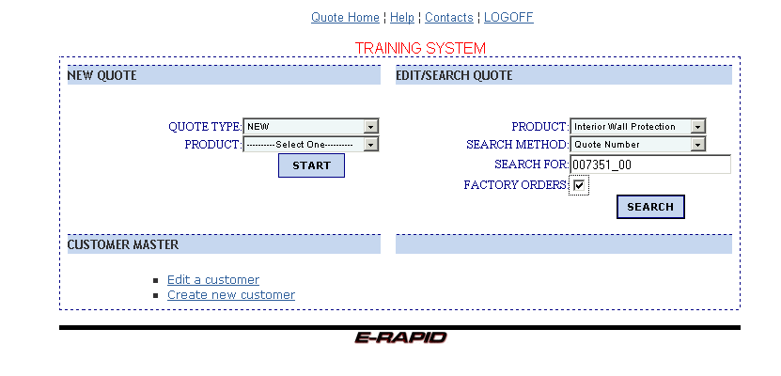
Step 2: After hitting the search button, you will get the familiar quote list screen:

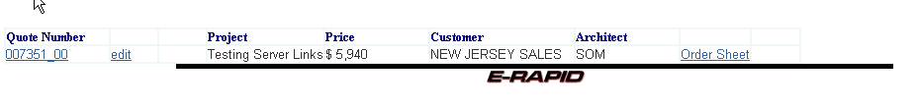
From here, you can go to the header by clicking the quote number, where you can add your customer and any notes that you may want to see on the quote.

Step 3: Using the header, you see the familiar screen, where you can select the customer name:

NOTE: If you are preparing an order for this quote, remember to change the Quote Satus to CLOSED and the Type to ORDER (the top entries on the header).
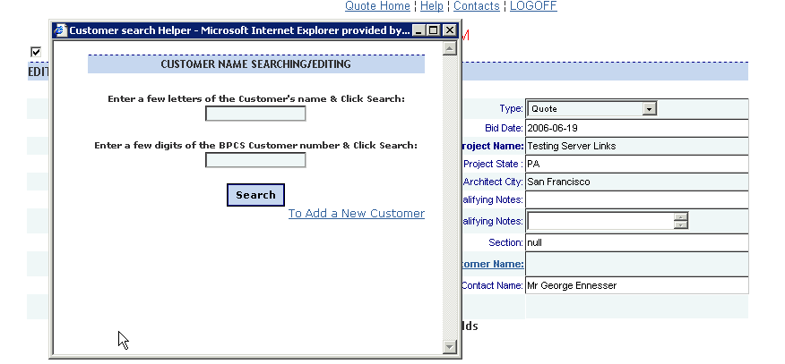
Step 4: Clicking on the REP NOTES link will allow you to add notes to the factory quotation:

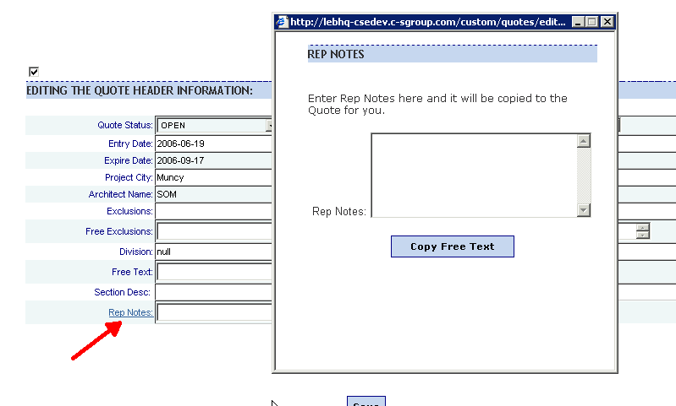
Step 5: After hitting “copy free text”, and then the SAVE button on the header screen, you will be at the familiar line item screen:

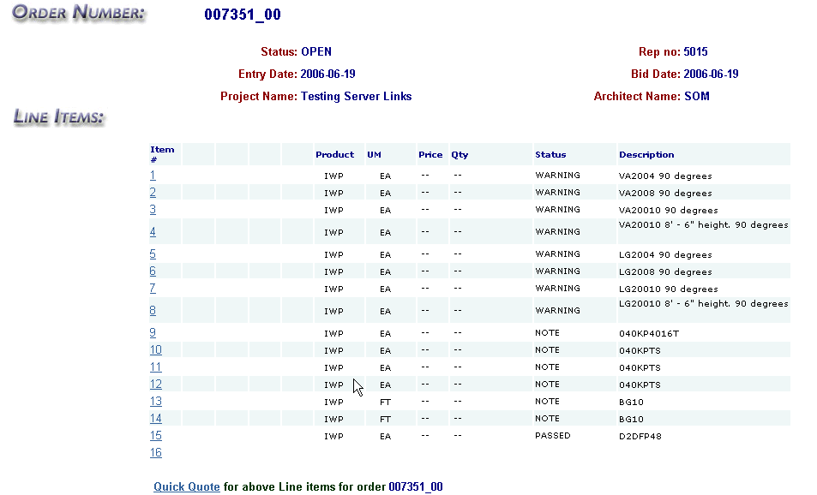
Notice that you can not edit any lines. In order to have any line edited, you must contact the factory.

NOTE: If you are preparing an order for this quote, click the ORDER WRITE-UP link on this screen, and continue with the familiar Order write-up

Step 6: Hit the Quick Quote link to get your finished quote, and bring-up the familiar price calculator:

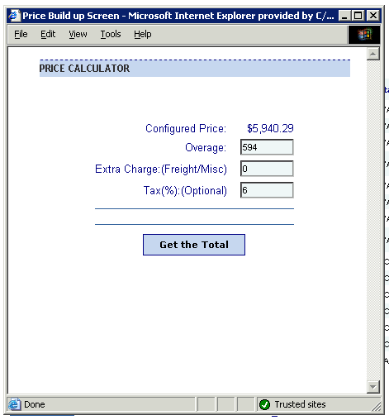
Notice the ability to add overage, special freight, and a tax rate. Hit “get the total” to see the effects of the price calculator:

(NOTE: The factory regulates overage – please refer to eRapid help guidelines or contact your factory sales office for assistance and guidance.)
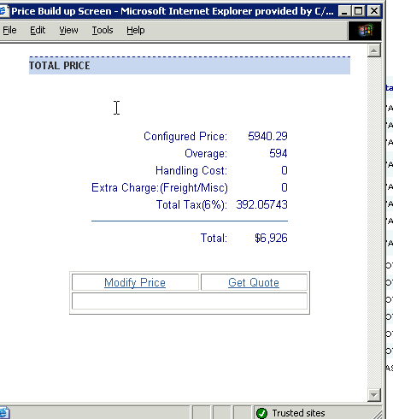
Step 7: Select the Get Quote link . . . Note that the factory designates the type of quote you will be getting, either Plans and Specs, or Types and Quantities. In order to change the type, you must contact the factory. The finished product is an html quote as depicted in part below:

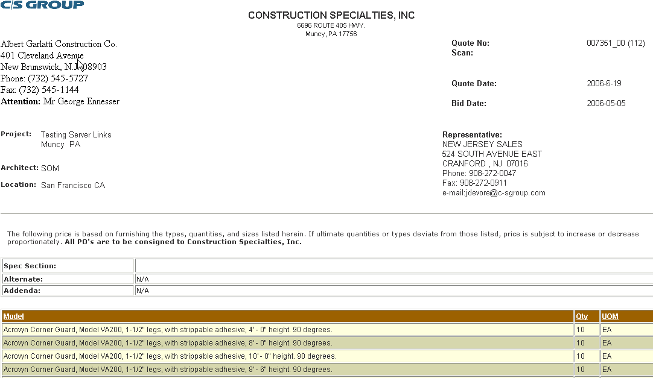
Notice the customer above, as well as note placement and tax information below.

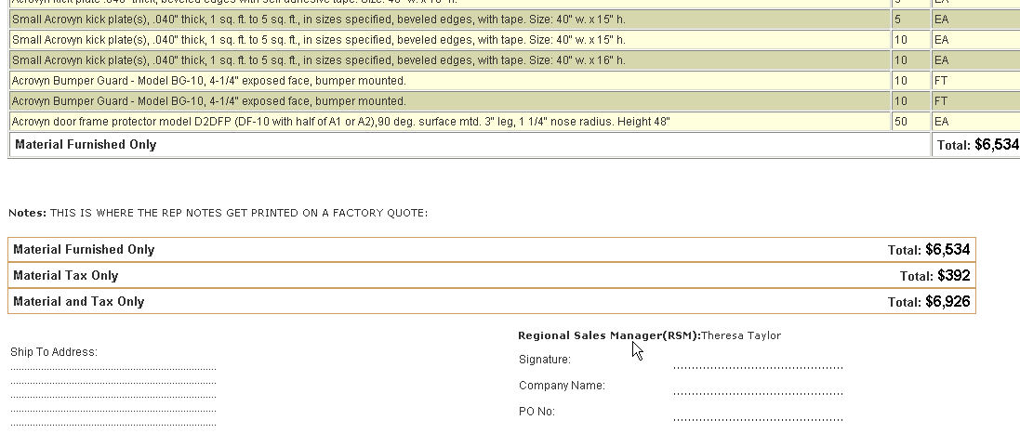
Step 8: Print and send, and repeat as necessary for multiple customers – simply close this quote back to the line item screen, select a line number to return to the header screen, and change your customer, repeating steps 3 through 8.

